|  |  |
| --- | --- |
| AGE | 45 |
| OCCUPATION | Businessman |
| MARITAL STATUS | Married |

**LOYAL BUSY COMMITTED**

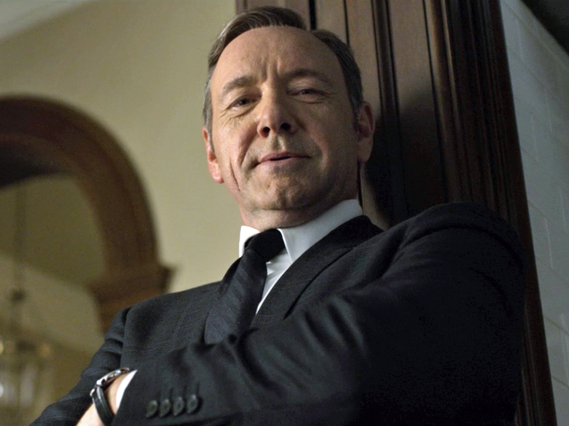

“I will be very happy if I am able to book an appointment quicker, given various privileges and some human connection through the website .”

EXPECTATIONS

* Friendly greetings as soon as he logs in to the account
* Discounts and deals on various dental treatments
* Suggestions about specialized doctors while booking an appointment
* Quicker processing of the appointment requests
* Live chat option with a medical representative

FRUSTRATIONS

* Reentering the same information every time he books an appointment
* Long waiting periods while seeking customer service

PERSONAL INTERESTS

* Enjoys playing video games and chess
* Farming

BIO

Frank is a businessman and is a frequent visitor to the hospital from the last 10 years. Being a businessman, he would like to book an appointment very quickly. He even expects some suggestions regarding the specialists, for a particular problem, based on the previous visits. He would feel very happy if given special discounts for being a loyal customer and if given special privileges through the website. Frank would also love to provide some feedback in improving the customer service.